1. Introduction to Style

Ensured elements are styled for focus and aria states, flexible UIs, and color choices.

1. Working with focus styles

It should be apparent which element has keyboard focus.

:focus { outline: 1px dotted #FFF; } // never set to 0 unless using alternative.

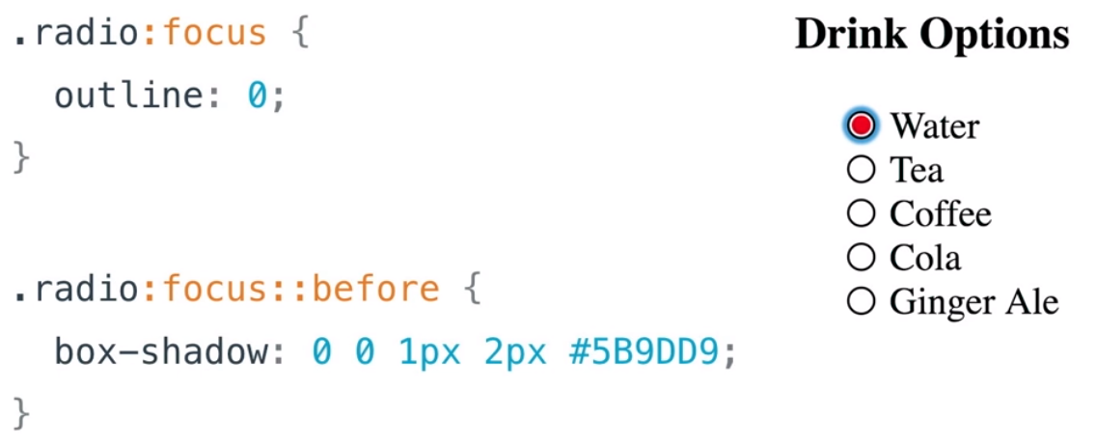

1. Quiz: Write your own focus styles
2. Input Modality
3. Styling with Aria
4. Quiz: Styling with ARIA
5. Responsive design for multi-device
6. Responsive design for multi-device Pt. 2

Zooming like crazy makes Udacity mobile.

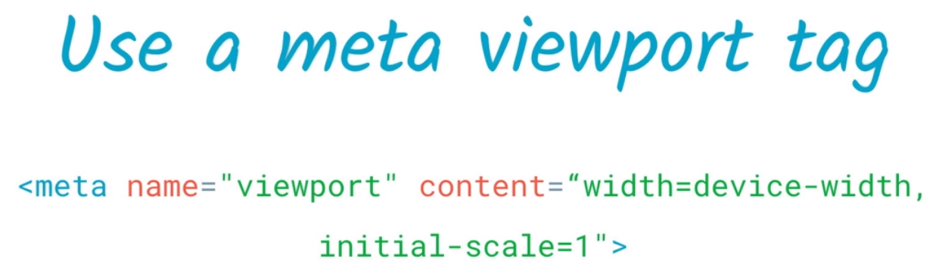

Design with a responsive grid.

1. Mobile Screen Readers
2. Mobile Screen Readers iOS
3. Mobile Screen Readers Android
4. Quiz: Using Mobile Screen Readers
5. Segue to Color &amp; Contrast
6. Meeting Contrast Requirements

Minimum 4.5:1 contrast ratio. Try to go to 7:1 so everyone can read everything.

Dev tools > audit > accessibility.

1. Quiz: Contrast Audit
2. Don’t convey info with color alone

1/12 Men and 1/200 Women have trouble seeing colors.

Color alone should not be used of conveying content or distinguishing visual elements.

1. High Contrast Mode

Allows inverted foreground and background colors.

Using this to test the website for readability is a good idea!

1. Outro
2. Course Outro

Ensure all users can access your content! Empathy is imperative.

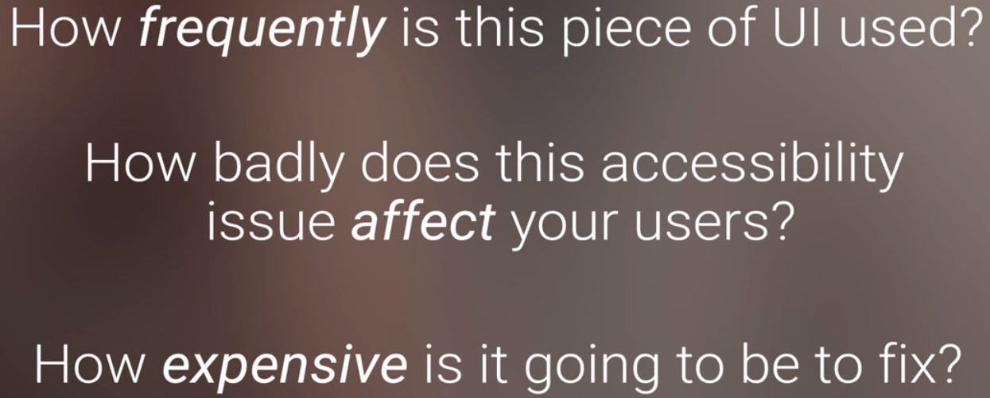

Good a11y = good UX